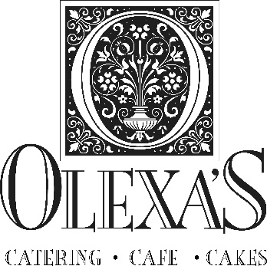
Bridal Cake Pricing
Cake
$4.25/ serving for stucco cake
$4.95 /serving for smooth or patterned cake
$5.25+/serving for specialty patterns
*additional for specialty flavors

Cake Embellishments
$65 - $265+ for florals
$25 - $400+ for fondant appliqués (pearls, bows, sashes, cut-outs)
$175 - $250 for false layers
*additional cost for ribbons and bows

Rentals
$45.00 for cake stand rental
$75.00 for fabric box rental

Delivery and Set-Up
$45.00 for 1-tier cake
$65.00 for 2-tier cake (50-75 servings)
$75.00 for 3-tier cake (100-175 servings)
$85.00 for 4-tier cake (200-275 servings)
$95.00 for 5-tier cake (325+ servings)
*additional cost for distance and added layers

Appointments
Our available appointment times are Tuesdays - Fridays at 2pm and 3pm.
Finalize 3 weeks prior to wedding date
Payment is due with cash, check or cashier’s check 2 weeks prior to wedding date. No credit cards.
$250.00 deposit for holding the wedding date
9.0% tax

Thank you for choosing the best for your guests with Olexa’s bridal cakes!

2838 Culver Road ~ Mountain Brook, Alabama 35223
Www.Olexas.com ~ 205.871.2060 ~ Eat@Olexas.com

