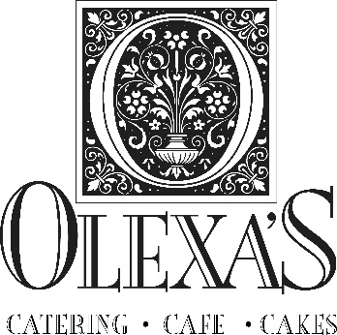
Bridal Cake Pricing 2022
Cake
$4.25-5.95 per slice
$4.25 per serving for stucco cake, semi-naked, spackle for 325+ servings / $5.25 for 50-300 servings
$4.95/ serving for linear, smooth, patterns for 325+ servings / $5.95 serving for 50-300 servings
*additional for specialty flavors
Cake Embellishments
$65 and up for florals
$25 - $400+ for fondant appliqués (pearls, bows, sashes, cut-outs)
$247.5 to $595.00 for faux layers
*additional cost for ribbons and bows, chocolate ganache, sauces
Rentals
$55.00/$65.00/ 75.00 and up for cake stand rentals
Delivery in Bham area/ Set-Up
$50.00 for 1 tier cake (25- 200 servings)
$75.00 for 2 tier cake (50-75 servings)
$100.00 for 3 tier cake (100-175 servings)
$125.00 for 4 tier cake (200-275 servings)
$150.00 for 5 tier cake (325+ servings)
$175.00 for 6 tier cake (325+ servings)
$200.00 for 7 tier cake (400+ servings)
*additional cost for distance and added layers
Appointments
Our available appointment times are Tuesdays, Wednesdays & Thursdays at 2 pm and 3 pm.
Finalize appointments are requested 3 weeks prior to wedding date
DEPOSITS
Credit cards are accepted on all wedding cake deposits only.
$300.00 deposit for holding the wedding date
PAYMENT
Payment is due with cash, personal check or cashier’s check 2 weeks prior to wedding date.
Cash, Cashier’s checks, Personal check accepted 2 weeks prior to wedding date.
Cash and Cashier’s check only are accepted 7-13 days prior to wedding date.
Credit Cards are not accepted on partial or final payments for wedding cakes.
9% tax

Thank you for choosing Olexa’s
the best for your guests!

2838 Culver Road ~ Mountain Brook, Alabama 35223
www.Olexas.com ~ 205.871.2060 ~ Eat@Olexas.com

